|  |  |
| --- | --- |
| Command | Description |
| pwd | To Know the present working directory |
| sudo -i / sudo su - | To switch to root user from ubuntu user |
| ls | To list files & folders in the current directory |
| ls -l | To list files & folders in a long-listed way with permissions |
| ls -al | To list all hidden files along the previous command |
| mkdir | To create a directory in the current location |
| rm -r | To delete a directory |
| cp | copy a file/ directory |
| touch | Create an empty file |
| vi | Creates and empty file and opens it for Editing |
| cat | To read/display the contents of a file. |
| cat file2 > file3 | Merge contents of file2 into file3 |
| mv | To rename a file / directory & To move location of file/directory to new location |
| cd | change directory |
| cd .. | Go back to one directory |
| cd ../.. | Go back to two directories |
| cd <path> | Change the current directory to the <path> (new directory location) |
| adduser | To create a new user in Linux |
| userdel -r | To delete any user and its home directory. |
| su - <username> | To switch user from one user to other |
| chmod | change file/folder permissions |
| chmod -R | change file/folder permissions recursively to subfolders also |
| chown <username> <groupname> | Change the ownership and group name of a file/folder |
| man <command name> | Gives help information on a command |
| history | Gives a list of all past commands |
| clear | Clears the terminal |
| usermod -a -G GROUPNAME USERNAME | To add a user to a group |
| deluser USER GROUPNAME | To remove a user from a group |

Create User:

* Basing on which user you are logged in
  + For non-root user
    - sudo adduser <username>
  + For Root user
    - Adduser <username>
* Output of the above commands with ask you to create passwd for the user.

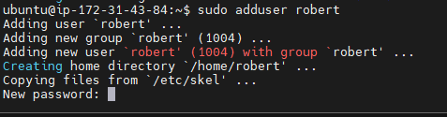

* After we give password, it will ask few questions which are optional

* After we create a user to switch into user

su - username